Working from home guidelines

Ministerial Service recognises the potential benefits of providing flexible working arrangements that will assist staff members with balancing the demands of work with their family and/or personal responsibilities.

This guideline aims to provide guidance to staff members in Ministerial Offices on the implementation of working remotely.

Your checklist for working flexibly:
- Communicate with your team in advance regarding flexible work arrangements.
- Keep a shared calendar of all flexible arrangements

- Do you have a stable internet connection at home?
- If not, consider tethering to your mobile or discuss options with your Chief of Staff.
- Please note connecting to public Wi-Fi is not advisable on ministerial services-issued devices.

- Do you have a spare charger for your device(s) at home?
- If not, speak to the IT Service Desk.

- Are you able to access relevant systems and resources using a remote connection?
- Where possible, do a trial run to test connections if you are planning on working remotely. Some key connections to test include: Outlook, Ministerial Intranet, Skype for Business, electronic files.

- Have you got your desk phone forwarded to a mobile device?
- If this is not a preferred method of receiving calls, please discuss with your Chief of Staff.

- Useful contacts:
- Ministerial Services Information Line | (07) 3003 9700
- IT Service Desk | (07) 3035 5123
- Human Resources | (07) 3003 9079
- Finance/Administration | (07) 3003 9071
Health and Safety
When working remotely, it is important to prioritise your health and safety at all times by considering the following:
Hazards | Ensure stairs, pathways, floors, entrances are free from obstructions and trip hazards and are non-slip, well-lit and easily visible. This includes ensuring computer and electrical cords are located where they will not be damaged or present a tripping hazard.
Workstation | Ensure your work area and equipment are easily accessible without bending, reaching or twisting to reduce the risk of injury and fatigue.
Screens | To improve posture and reduce strain, it is recommended the distance between your eyes and display screen be approx. 450mm.
Seating | Ensure your chair is comfortable, with lower back support, easily adjustable features and rounded front seat pan.
Lighting | Ensure you have sufficient lighting without glare, reflections, awkward postures or squinting/straining of the eyes. The best light is natural light which can help improve your mood and concentration.

Noise | Ensure noise in the immediate work area is low. Consider noise-cancelling headphones to reduce distractions.
Climate | Ensure sufficient airflow levels, temperature and humidity are maintained.
Breaks | Improve your overall health and posture by taking regular breaks that incorporate stretching.

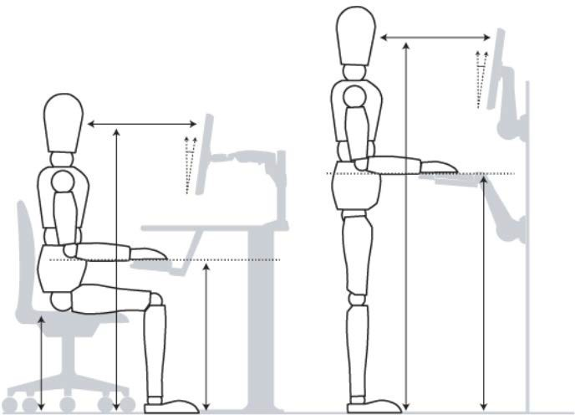
Ergonomic tips for your workstation:
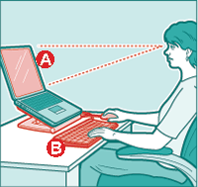
When using a laptop for extended periods, elevate it so the screen is at eye level (A). Then plug in an external keyboard and pointing device (B) so you can type without strain. It is also important to adjust your chair height, so your arms and thighs are parallel to the floor and your feet are flat on the floor.

Strategies for successful flexible arrangements:
- Establish clear guidelines, expectations and deliverables with your Chief of Staff
- Ensure online communication channels have been established to facilitate instant messaging and teleconferencing (Skype for Business).
- Advise team when online/offline (start/finish/breaks).
- Adopt a structure similar to a day worked in the office including establishing clear start/finish times and ensuring regular breaks are taken.
- Communicate expectations to anyone who will be at home to ensure minimal disruption.
- Consider logging out of social media accounts or muting notification
- Be mindful of your environment when on work calls working from a quiet room to reduce distracting background noise or using headphones.

